Circle Computer Resources honored as a 2023 VETS Indexes Recognized Employer
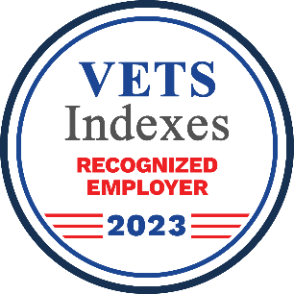

Cedar Rapids, Iowa – April 13, 2023 – VETS Indexes is excited to announce that Circle Computer Resources has earned the designation VETS Indexes Recognized Employer in the 2023 VETS Indexes Employer Awards. The award recognizes the organization’s commitment to recruiting, hiring, retaining, developing, and supporting veterans and the military-connected community.

Click this link to see the full slate of awardees: https://vetsindexes.com/award-results-2023

Heidi Hromidko, VP of Human Experience, said, “Veterans are a valuable asset at CCR. They possess a diverse skill set gained from their military service that is highly transferable to civilian work environments. They are often trained in various technical, leadership, and problem-solving skills that can be applied to a wide range of job roles.”

“Circle Computer Resources has demonstrated a commitment to recruiting veteran and military-connected team members, and then helping them grow and develop into leaders,” said George Altman, managing director of VETS Indexes.

“As more and more employers recognize the cutting-edge technical skills and soft skills veterans bring to the workplace, the race to attract military-connected talent gets increasingly competitive. The number of organizations participating in the 2023 VETS Indexes Employer Awards more than doubled since last year – but even in this highly competitive environment, Circle Computer Resources distinguished itself among veteran employers and should be commended,” Altman said.

This year, a record number of 239 organizations participated in the VETS Indexes Employer Awards, more than double the 118 participants in 2022. Of those, VETS Indexes recognized 200 organizations across the following award levels: 5 Star Employer, 4 Star Employer, 3 Star Employer, and Recognized Employer. Not every responding organization made the cut – only those that demonstrated a strong commitment to veterans, members of the National Guard and Reserves, and military spouses. Participating organizations included companies large and small, government agencies and departments, nonprofit groups, colleges, and universities.

As the most objective and comprehensive evaluation of veteran employers, the VETS Indexes Employer Awards program has set a new standard in veteran employment data. Our award results have been featured on CNBC, as well as military-specific outlets, including Military.com. This in-depth survey and recognition program analyzes employers’ policies, practices, and outcomes in detail, across the following 5 categories:
- Veteran job candidate recruiting and hiring
- Veteran employee development and retention
- Veteran-inclusive policies and culture
- Support for members of the National Guard and Reserves
- Military spouse/family support

For more information on the process and methodology behind the VETS Indexes Employer Awards, please click this link: https://vetsindexes.com/employer-awards-methodology. To register and participate in the upcoming 2024 VETS Indexes Employer Awards competition, please click here: https://vetsindexes.com/employer-awards/.

About CCR
CCR (Circle Computer Resources, Inc.) was founded in 1986 and is committed to providing business technology services that create lasting solutions for clients both local and across North America. CCR values the knowledge of its staff and their ability to stay current with the ever-changing trends in their field, providing the most viable and comprehensive services the market has to offer. CCR is the recipient of numerous awards, nominations, and distinctions, including the Technology Association of Iowa’s Prometheus Awards, HIRE Vets Medallion, and the Great Place to Work certification.

To learn more, visit ccr.net and join the community on Facebook, LinkedIn, and Instagram.

CCR’s Media Contact: Lynette Hemann | lynette.hemann@ccr.net

About VETS Indexes
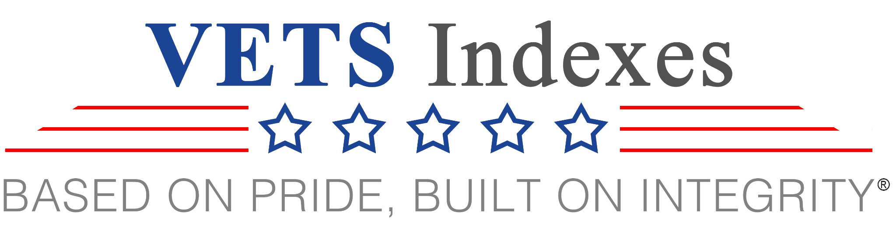

VETS Indexes is a leading voice on veteran employment issues, overseeing the VETS Indexes Employer Awards, hosting the twice-yearly Employing U.S. Vets Conference, unearthing unique and unprecedented data on veteran employment through the Veteran Employment Benchmarking Service, and developing custom indexes, linked to financial products, that track the performance of the publicly traded companies that have established themselves as the best employers for veterans.

The VETSX and VTRNIX indexes were created on the premise that the companies that make the best use of the highly talented, yet under-valued, talent pool that veterans represent will ultimately see a benefit to their bottom lines. The performance of the indexes has emphatically confirmed that thesis, outpacing the S&P 500.

As the world’s first resource for U.S. veteran themed indexes, our mission is to provide innovative solutions that recognize the value created by the mission-critical mindset, unique skills, and specialized training that veterans bring to the workplace. Our mission also includes a commitment to always donate a significant portion (target of 20% and no less than 5%) of our net profits to charitable organizations that support veterans and their families.

“SERVING THOSE WHO SERVED” - VETS Indexes provides a social and governance impact via those public companies that support the hiring and professional development of our military veterans.

Learn more about us at VETSIndexes.com and follow us on social media channels via LinkedIn, Facebook and Twitter.

VETS Indexes Contact: Nick Antaki | nantaki@vetsindexes.com

