Circle Computer Resources Ranked on Channel Futures 2023 MSP 501—Tech Industry’s Most Prestigious List of Managed Service Providers Worldwide
Annual MSP 501 Identifies Industry’s Best-in-Class Businesses
Growing Via Recurring Revenue and Innovation

Cedar Rapids, Iowa – June 23, 2023 – CCR (Circle Computer Resources) has been named as one of the world’s premier managed service providers in the prestigious 2023 Channel Futures MSP 501 rankings.

For the past 17 years, managed service providers around the globe have submitted applications for inclusion on this prestigious and definitive listing. The Channel Futures MSP 501 survey examines organizational performance based on annual sales, recurring revenue, profit margins, revenue mix, growth, innovation and supported technologies.

MSPs that qualify for the list must pass a rigorous review conducted by the research team and editors of Channel Futures. It ranks applicants using a unique methodology that weighs financial performance according to long-term health and viability, commitment to recurring revenue and operational efficiency.

Channel Futures is pleased to name CCR (Circle Computer Resources) to the 2023 MSP 501. CCR increased its ranking from #159 in 2022 to #46 in 2023, and is one of only three Iowa companies in the top 100.

This year’s list is one of the most competitive in the survey’s history. Winners will be recognized on the Channel Futures website and honored during a special ceremony at the Channel Futures Leadership Summit, Oct. 30-Nov. 2, in Miami, Florida.

Since its inception, the MSP 501 has evolved from a competitive ranking into a vibrant group of innovators focused on high levels of customer satisfaction at small, medium and large organizations in public and private sectors. Many of their services and technology offerings focus on customer needs in the areas of cloud, security, collaboration and hybrid work forces.

“The 2023 Channel Futures MSP 501 winners persevered through challenging times to become the highest-performing and most innovative IT providers in the industry today,” said Jeff O’Heir, Channel Futures senior news editor and MSP 501 project manager. “The MSP 501 ranking doesn’t award MSPs solely on their size and revenue. It acknowledges the business acumen, best practices and trusted advice they deliver to customers every day. They deserve the honor.”

“We extend our heartfelt congratulations to the 2023 winners, and gratitude to the thousands of MSPs that have contributed to the continuing growth and success of the managed services sector,” said Kelly Danziger, general manager of Informa Tech Channels. “These providers are most certainly driving a new wave of innovation in the industry and are demonstrating a commitment to moving the MSP and entire channel forward.”

The data collected by the annual NextGen 101 and MSP 501 drive Channel Futures’ market intelligence insights, creating robust data sets and data-based trend reports that support our editorial coverage, event programming, community and networking strategies and educational offerings.

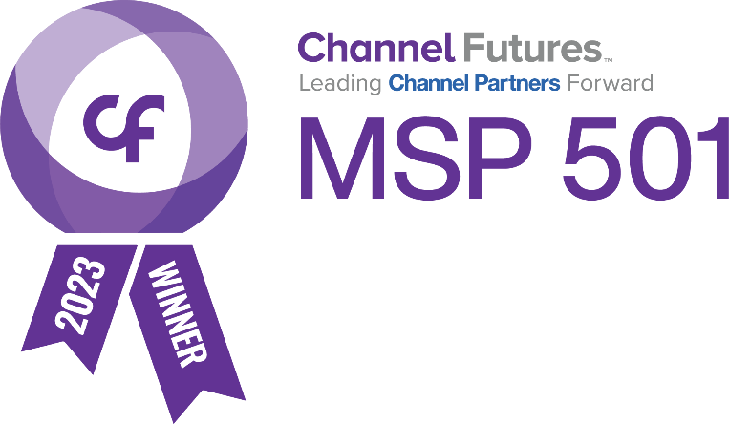

Background
The 2023 MSP 501 list is based on confidential data collected and analyzed by the Channel Futures research and editorial teams. Data was collected online from February to May 2023. The MSP 501 list recognizes top managed service providers based on metrics including recurring revenue, profit margin and other factors.

About CCR
CCR (Circle Computer Resources, Inc.) was founded in 1986 and is committed to providing business technology services that create lasting solutions for clients both local and across North America. CCR values the knowledge of its staff and their ability to stay current with the ever-changing trends in their field, providing the most viable and comprehensive services the market has to offer. CCR is the recipient of numerous awards, nominations, and distinctions, including the Technology Association of Iowa’s Prometheus Awards, HIRE Vets Medallion, and the Great Place to Work certification.

To learn more, visit ccr.net and join the community on Facebook, LinkedIn, and Instagram.

CCR’s Media Contact: Lynette Hemann | lynette.hemann@ccr.net

About Channel Futures
Channel Futures is a media and events destination for the information and communication technologies (ICT) channel community. We provide information, perspective and connection for the entire channel ecosystem, including solution providers (SPs), managed service providers (MSPs), managed security service providers (MSSPs), cloud service providers (CSPs), value-added resellers (VARs) and distributors, technology solutions brokerages, subagents and agents, as well as leading technology vendor partners and communication providers.

Our properties include many awards programs such as the Channel Futures MSP 501, a list of the most influential and fastest-growing providers of managed services in the technology industry; Channel Partners events, which delivers unparalleled in-person events including Channel Partners Conference & Expo, Channel Futures Leadership Summit, Women’s Leadership Summit, the MSP Summit and Channel Partners Europe; and a DEI Community Group, our initiative to educate, support and promote diversity, equity and inclusion (DE&I) in the ICT channel industry. Channel Futures is where the world meets the channel; we are leading Channel Partners forward. More information is available at channelfutures.com.

Channel Futures is part of Informa Tech, a market-leading B2B information provider with depth and specialization in ICT sector. Every year, we welcome 14,000+ subscribers to our research, more than 4 million unique monthly visitors to our digital communities, 18,200+ students to our training programs and 225,000 delegates to our events.

Channel Futures Media Contacts:
Jeff O’Heir
Channel Futures Senior News Editor, MSP 501 Manager
Jeff.oheir@informa.com

Ginette Andre
Associate Marketer, VIP Relations
ginette.andre@informa.com

